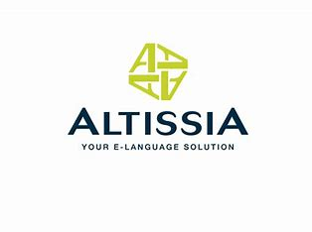1 TI IR IG

Present Simple vs Present continuous

<https://learn.altissia.org/platform/#/discover/GRAMMAR/PRESENT/lesson/EN_GB_A1_GRAMMAR_PRESENT_CONTINUOUS>

<https://learn.altissia.org/platform/#/discover/GRAMMAR/PRESENT/lesson/EN_GB_A1_GRAMMAR_PRESENT_SIMPLE_TO_BE>

<https://learn.altissia.org/platform/#/discover/GRAMMAR/PRESENT/lesson/EN_GB_A1_GRAMMAR_PRESENT_SIMPLE_TO_HAVE_OTHER_VERBS>

Simple Past vs Past Continuous

<https://learn.altissia.org/platform/#/discover/GRAMMAR/PAST/lesson/EN_GB_A1_GRAMMAR_SIMPLE_PAST_TO_BE>

<https://learn.altissia.org/platform/#/discover/GRAMMAR/PAST/lesson/EN_GB_A1_GRAMMAR_SIMPLE_PAST_REGULAR_AND_IRREGULAR_VERBS>

<https://learn.altissia.org/platform/#/discover/GRAMMAR/PAST/lesson/EN_GB_A2_GRAMMAR_PAST_CONTINUOUS>